Encapsulation in Java
Encapsulation is one of the four fundamental pillars of Object-Oriented Programming (OOP) in Java, alongside inheritance, polymorphism, and abstraction. At its core, it is the mechanism of bundling data (fields) and the methods that operate on that data together within a single class, while restricting direct access to the internal state from outside.^{[1][2]}
A helpful real-world analogy: think of a capsule pill — the medicine (data) is wrapped and protected inside; you interact with it only in the prescribed way, not directly.

Core Idea: Data Hiding
Encapsulation achieves data hiding by preventing external code from directly reading or modifying an object's fields. Instead, all interactions happen through controlled methods. This ensures the internal state of an object is always valid and consistent.^{[3][4]}

How to Implement Encapsulation
Implementing encapsulation in Java follows two key rules:^{[5]}
- Declare fields as private — so they cannot be accessed directly from outside the class.
- Provide public getter and setter methods — to allow controlled reading and writing of those private fields, optionally with validation logic.
Example:
class Employee {
// Private fields — hidden from outside
private String name;
private int age;
private double salary;
// Getter for name
public String getName() {
return name;
}
// Setter for name
public void setName(String name) {
this.name = name;
}
// Setter for age with validation
public void setAge(int age) {
if (age > 0) {
this.age = age;
} else {
System.out.println("Please enter a valid age.");
}
}
public int getAge() {
return age;
}
// Setter for salary with validation
public void setSalary(double salary) {
if (salary > 0) {
this.salary = salary;
} else {
System.out.println("Salary must be positive.");
}
}
public double getSalary() {
return salary;
}
}
public class Main {
public static void main(String[] args) {
Employee emp = new Employee();
emp.setName("John Doe");
emp.setAge(30);
emp.setSalary(50000);
System.out.println("Name: " + emp.getName());
System.out.println("Age: " + emp.getAge());
System.out.println("Salary: " + emp.getSalary());
}
}
Notice how setAge() rejects negative values — this is the power of encapsulation. You control what gets stored.^{[4]}

Types of Encapsulation
There are three main ways encapsulation manifests in Java:
Type | Description
Member Variable Encapsulation | Declaring fields as private and using getters/setters to access them
Method Encapsulation | Restricting method visibility using access modifiers (private, protected)
Class Encapsulation | Keeping related data and methods within one class to promote reusability and security

Access Modifiers in Encapsulation
Access modifiers are the tools that enforce encapsulation:^{[5]}
- private — accessible only within the same class (used for fields)
- default (no modifier) — accessible within the same package
- protected — accessible within the same package and subclasses
- public — accessible from anywhere (used for getters/setters)

Benefits of Encapsulation
- Data security — sensitive fields cannot be tampered with directly from outside^{[3]}
- Input validation — setters can enforce rules before assigning values (e.g., no negative age)^{[4]}
- Improved maintainability — internal implementation can change without affecting external code^{[7]}
- Modularity — each class manages its own state independently, making the system easier to debug and extend^{[4]}
- Read-only or write-only fields — you can expose only a getter (read-only) or only a setter (write-only) depending on your need

Disadvantages of Encapsulation
- Increased Code Complexity: Writing getter and setter methods for every variable can make the code longer and slightly more complex.
- Performance Overhead: Accessing data through methods instead of directly can introduce a minor performance cost, especially in performance-critical applications.
- Less Flexibility in Some Cases: Over-restricting access to class members may limit the ability of other classes to extend or use the class efficiently

Encapsulation vs. Abstraction
These two are often confused, but they serve different purposes:
Aspect | Encapsulation | Abstraction
Focus | How data is protected | What information is shown
Mechanism | Private fields + getters/setters | Abstract classes, interfaces
Goal | Data hiding and controlled access | Hiding complexity, showing only essentials

Best Practices
- Always declare class fields as private by default
- Add validation logic inside setters to maintain object integrity
- Expose only what is necessary — avoid unnecessary getters/setter.
- Use final fields (with only a getter) for truly immutable data
In summary, encapsulation is the discipline of keeping an object in control of its own data, making Java code more secure, modular, and maintainable.

include the diagrams and block pictorial representations as well for all the topics
Here is a fully visual, diagram-enriched explanation of Encapsulation in Java, with three custom block diagrams covering every key concept.

What is Encapsulation?
Encapsulation is the OOP principle of bundling private data fields and the methods that control access to them inside a single class. The outside world cannot touch the fields directly — it must use the class's public methods (getters/setters) as a controlled gateway.^{[16][17]}

Architecture Block Diagram
The diagram below shows the complete encapsulation structure of a Java class. Private fields are locked inside the class boundary (red box), accessible only through the green getter methods (read) and orange setter methods (write). The purple "Outside World" block is blocked from direct field access but allowed to call public methods.^{[16]}
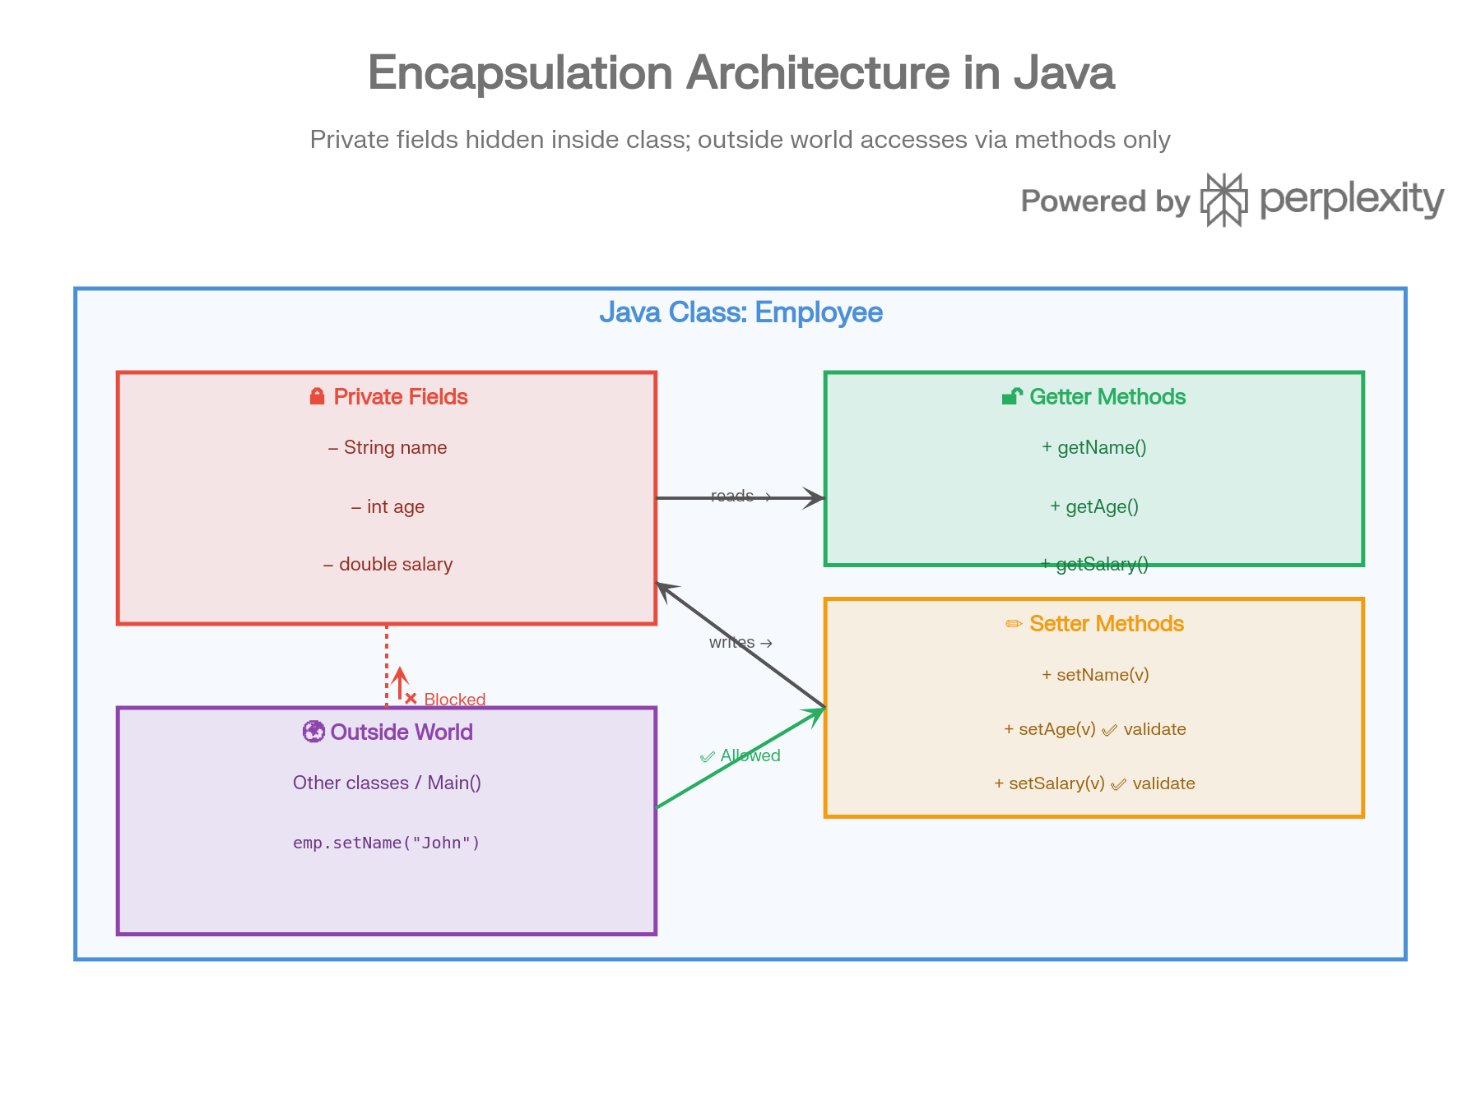

Access Modifiers Visibility Scope
Encapsulation is enforced using Java's four access modifiers. The diagram below shows exactly which scope each modifier covers — private is the most restrictive (same class only), while public is fully open.^{[16]}
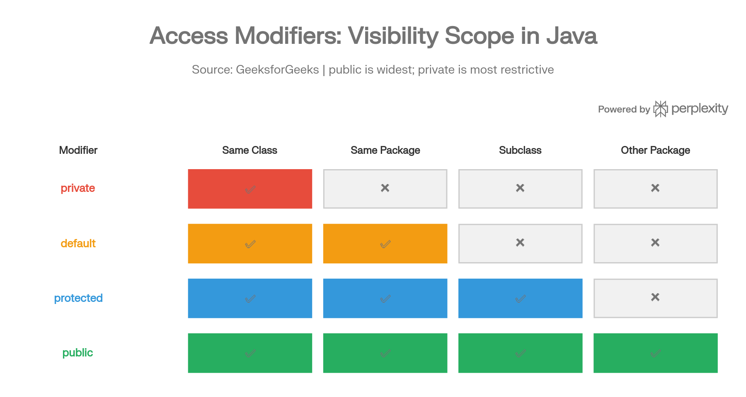
- private → Same class only (used for fields in encapsulation)
- default → Same package
- protected → Same package + subclasses
- public → Accessible from anywhere (used for getters/setters)

Setter Method Validation Flow
One of encapsulation's biggest powers is that setters can validate input before storing it to the private field. The flowchart below traces what happens when you call emp.setAge(-5):^{[18]}
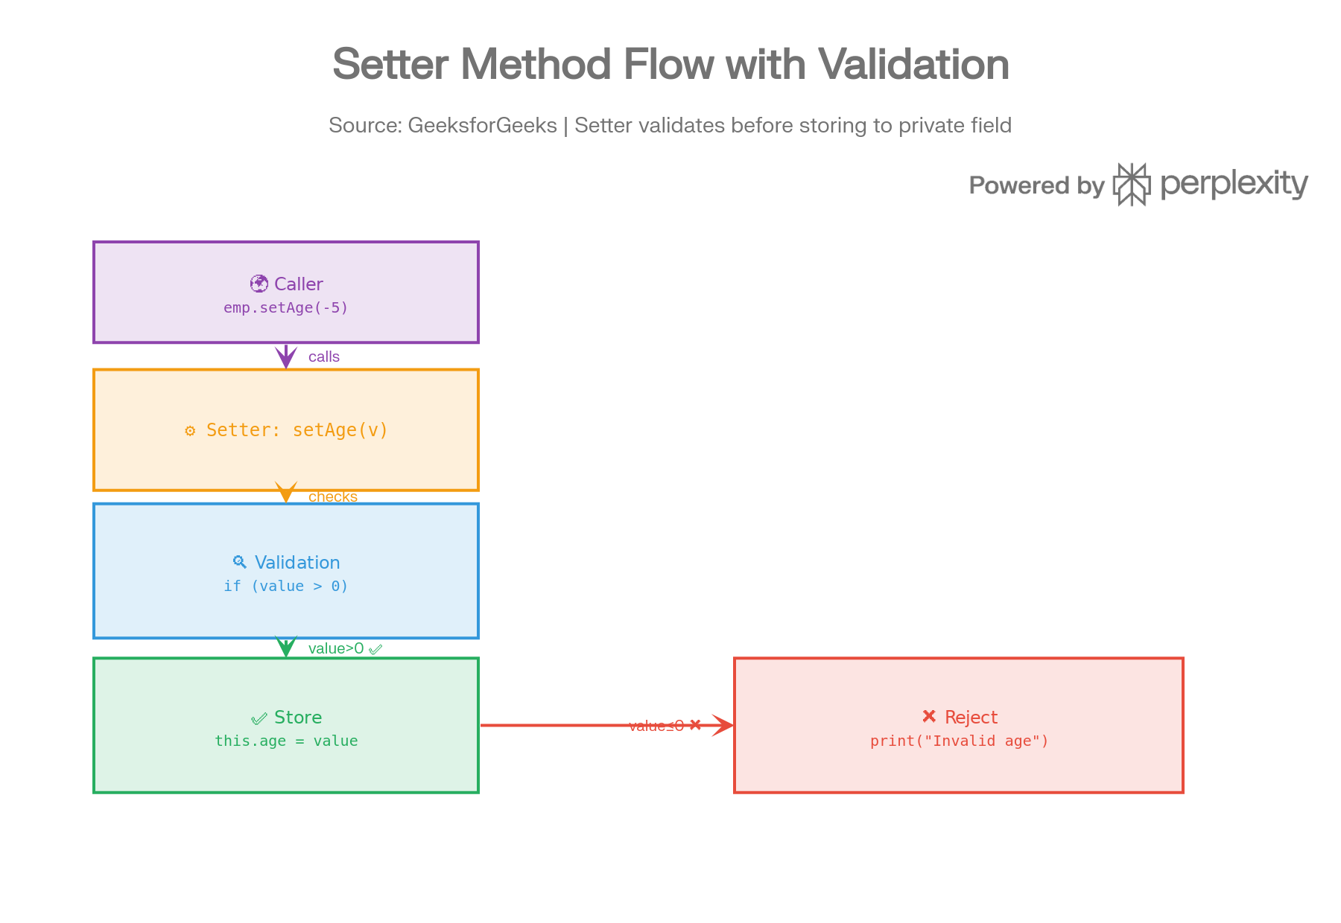
The setter intercepts the value, runs the if (value > 0) check, stores it if valid, or rejects it with an error message — the private field age is never corrupted.^{[18]}

How to Implement Encapsulation
class Employee {
private String name; // 🔒 Hidden
private int age;
private double salary;
public String getName() { return name; } // 🔓 Read
public void setName(String name) { this.name = name; }
public void setAge(int age) {
if (age > 0) this.age = age; // ✅ Validated write
else System.out.println("Invalid age!");
}
public int getAge() { return age; }
}
Declare fields private, expose them only via public getters and setters, and embed validation inside the setters.^{[16]}

Benefits vs. Drawbacks
Aspect | Detail
✅ Data Security | Fields can't be corrupted by external code ^{[19]}
✅ Validation | Setters enforce rules (e.g., no negative salary) ^{[18]}
✅ Maintainability | Internal logic changes don't break outside code ^{[16]}
✅ Modularity | Each class owns and manages its own state ^{[20]}
⚠️ Boilerplate | Writing getters/setters for every field adds code length ^{[16]}
⚠️ Minor Overhead | Method calls are marginally slower than direct field access ^{[16]}

Encapsulation vs. Data Hiding
These are often confused but are distinct concepts:
Aspect | Encapsulation | Data Hiding
Definition | Wrapping data + methods into one unit | Restricting direct access to data
Scope | Broader — includes structure & design | Narrower — security only
Mechanism | Classes + access modifiers + methods | private access modifier
Goal | Modularity + maintainability | Prevent misuse/accidental changes

